**Project: Obstacle Detection and Distance Measurement using CH32V and Ultrasonic Sensor**

**Objective**

Design a system that uses an ultrasonic sensor to detect obstacles and measure distances, displaying the results on an LCD display.

**Hardware Requirements**

1. CH32V microcontroller

2. Ultrasonic sensor (e.g., HC-SR04)

3. LCD display (e.g., 16x2 LCD)

4. Breadboard and jumper wires

5. Power supply (e.g., USB cable)

**Software Requirements**

1. VS Code for software development
2. PlatformIO multi framework professional IDE
3. Cirkit designer IDE for virtual simulation and circuit diagram

**Project Steps**

1. Initialize Ultrasonic Sensor: Configure the ultrasonic sensor to send and receive signals, using the CH32V's GPIO and timer peripherals.

2. Measure Distance: Use the ultrasonic sensor to measure the distance to an obstacle, calculating the time-of-flight and converting it to a distance value.

3. Display Distance on LCD: Send the measured distance value to the LCD display, displaying it in a user-friendly format.

4. Implement Obstacle Detection: Use the measured distance value to detect obstacles, triggering an alarm or warning message when an obstacle is detected within a certain range.

.

**Circuit Diagram**

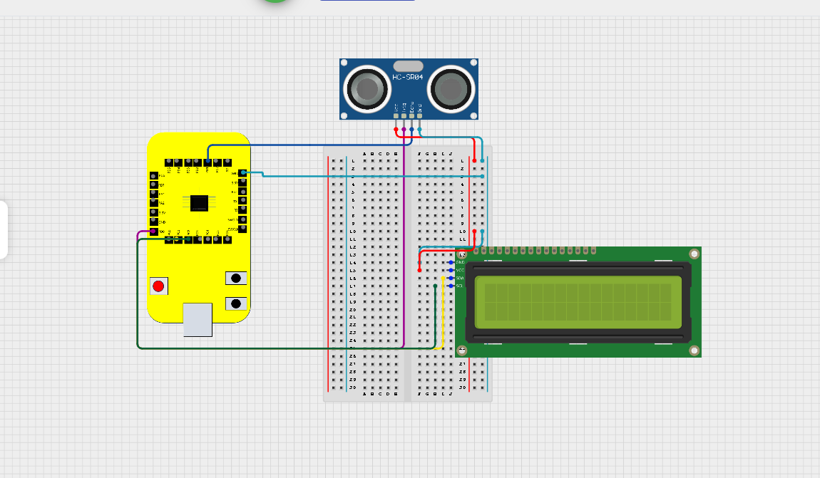

### LCD Display with I2C Interface Connections:

1. GND (1) -> VSD Squadron Mini GND
2. VCC (2) -> VSD Squadron Mini 5V
3. SDA (3) -> PC1 (SDA Pin)
4. SCL (4) -> PC2 (SCL Pin)

**Ultrasonic Sensor Connections:**

1. VCC -> +5V
2. GND -> GND
3. TRIG -> PD0
4. ECHO -> PD1